Delta organization model.

1. Delta Organization Overview
Delta is a mid-sized organization with three core departments — IT, HR, and Finance — each operating distinct services under a unified identity umbrella. IT is the custodian of infrastructure and access services. HR manages the employee lifecycle. Finance manages monetary operations. A fourth catch-all "Other Departments" tier accommodates future expansion (e.g., Legal, Operations).

2. SSO Architecture and Trust Model
Delta's SSO model follows a hub-and-spoke federation pattern:
- Identity Provider (IdP): Microsoft Entra ID (formerly Azure AD) acts as the central IdP. On-premises Active Directory syncs via Entra Connect.
- SSO Protocol: SAML 2.0 for legacy services; OpenID Connect (OIDC) / OAuth 2.0 for modern web apps.
- Trust Anchor: All service providers (SP) in each department register with the IdP. The IdP issues signed tokens (JWT or SAML assertions) that SPs validate.
- Session Tokens: Short-lived (1-hour access tokens, 8-hour refresh tokens with silent renewal). Privileged sessions (Finance, Red Team) are limited to 30 minutes with step-up MFA.
- Role Mapping: Entra ID groups map to department roles. A user in the IT group receives IT-scoped claims; cross-department access requires explicit role assignment.

3. Data Flow Diagram Description
Below is the DFD for Delta's SSO model. It shows the authentication flow from a user through the IdP to department services.DFD narrative: A user submits credentials to the SSO IdP, which performs MFA and issues a signed token. The API Gateway validates that token and routes the authenticated request to the appropriate department service based on the user's role claims. Every authentication event and service access is asynchronously fed to the central Audit & Log Store (SIEM).

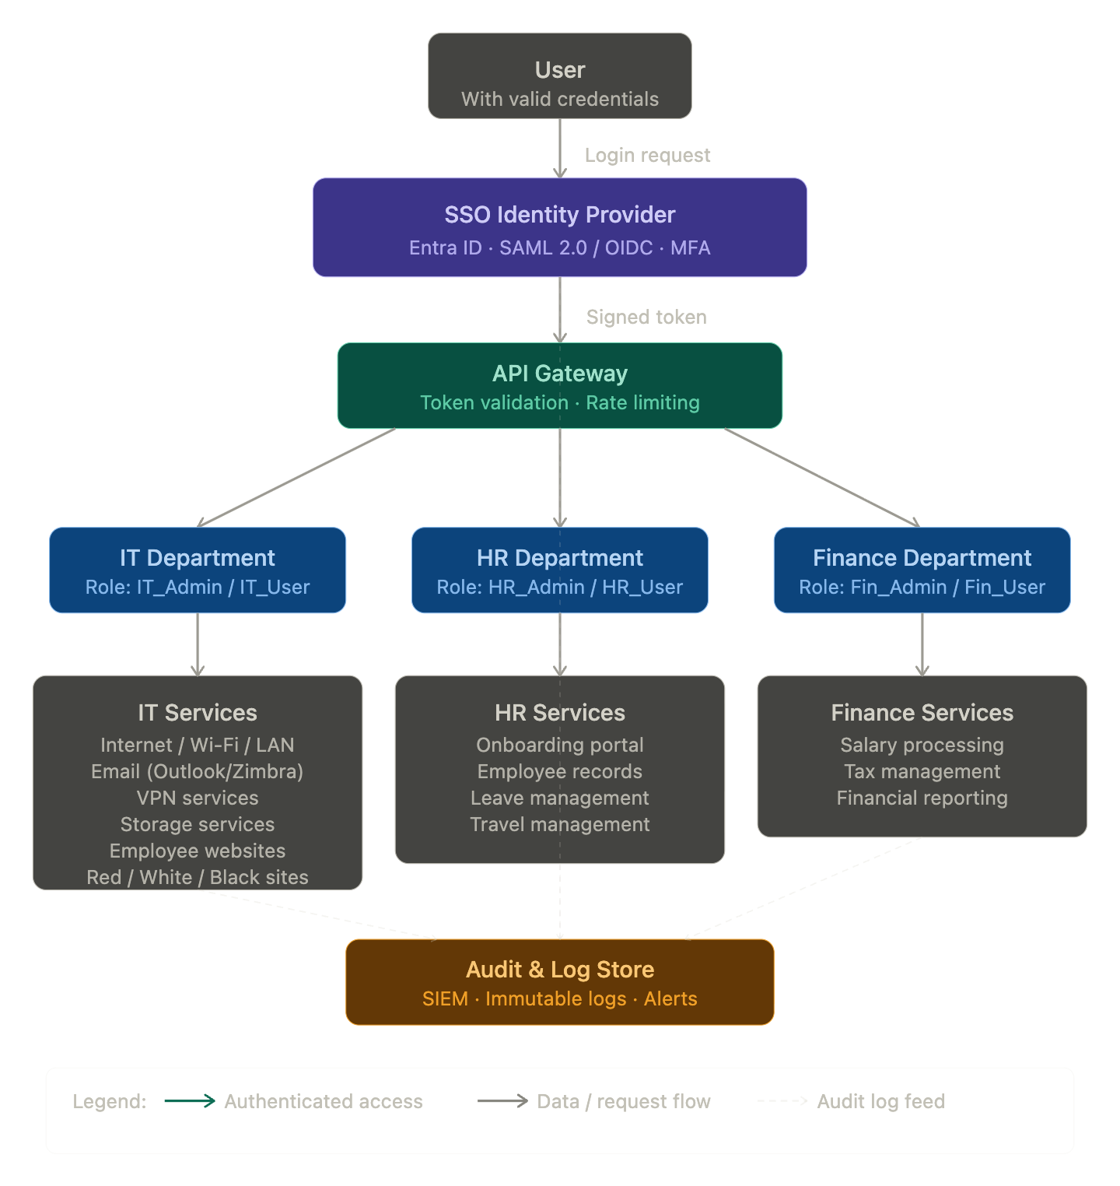

4. Ten Policies
P1 — Single Identity Policy: Every user must have exactly one identity account in Entra ID. Duplicate or shared accounts are prohibited.
P2 — Least Privilege Access: Users are granted the minimum role necessary for their job function. Cross-department access requires explicit approval and time-bounded assignment.
P3 — MFA Enforcement: All SSO logins require MFA (authenticator app or hardware token). SMS-based OTP is permitted only as a fallback for non-privileged users.
P4 — Privileged Session Timeout: Finance and IT Red Team sessions expire after 30 minutes of inactivity. Standard sessions expire after 60 minutes.
P5 — Data Residency Policy: All HR and Finance data at rest must reside within the approved jurisdiction (e.g., in-country or EU-compliant region). Data must not leave approved boundaries without CISO approval.
P6 — Encryption in Transit: All data in transit between any two Delta systems must be encrypted using TLS 1.2 minimum (TLS 1.3 preferred). Unencrypted protocols (FTP, HTTP) are prohibited.
P7 — Audit Logging Policy: All authentication events, privilege escalations, and data access events must be logged to the immutable SIEM. Logs must be retained for a minimum of 12 months.
P8 — Onboarding/Offboarding Synchronization: HR must notify IT within 24 hours of any employee status change. IT must provision or deprovision SSO accounts within 4 business hours of notification.
P9 — Vendor and Third-Party Access: External vendors must use a separate, time-limited guest identity. Guest accounts expire automatically after 30 days and cannot access Finance systems.
P10 — Incident Response Policy: Any suspected identity compromise must be reported to the SOC within 1 hour. The affected account must be suspended within 2 hours pending investigation.

5. Ten Requirements
R1 — SSO Availability: The IdP must maintain 99.9% uptime. Fallback authentication (break-glass accounts) must be available for critical systems if the IdP is unavailable.
R2 — Token Integrity: All SSO tokens must be cryptographically signed (RS256 for JWT, RSA-SHA256 for SAML). Token validation must occur at every service boundary.
R3 — Role-Based Access Control (RBAC): Every service must implement RBAC based on claims in the SSO token. Services must not maintain their own shadow user databases.
R4 — Encryption at Rest: All sensitive data (HR records, salary data, employee PII) must be encrypted at rest using AES-256. Key management must use a dedicated KMS (e.g., Azure Key Vault).
R5 — Secure Email Configuration: Email services must enforce DKIM, SPF, and DMARC. Microsoft Outlook/Exchange must have modern authentication enabled; Basic Auth must be disabled.
R6 — VPN Requirements: VPN services must enforce certificate-based or SSO-integrated authentication. Split tunneling for sensitive department traffic is prohibited.
R7 — Storage Access Control: Storage services must require authenticated access; no publicly accessible storage buckets are permitted. Access must be logged per R7's audit requirements.
R8 — Network Segmentation: IT, HR, and Finance systems must reside in logically separate network segments (VLANs or equivalent). Lateral movement between segments must require explicit firewall rules.
R9 — Vulnerability Management: All systems must be patched within 30 days of a critical CVE disclosure, and within 7 days for actively exploited vulnerabilities.
R10 — Disaster Recovery (DR): SSO and department services must have documented RPO ≤ 4 hours and RTO ≤ 8 hours. DR tests must be conducted at least annually.

6. Department-Wise Access, Encryption, and Authenticity Considerations
IT Department
Access is controlled via IT_Admin and IT_User roles in Entra ID. IT_Admin accounts have privileged access to infrastructure management consoles and are protected by hardware MFA tokens. Internet, VPN, and storage services validate the SSO token at the gateway layer. Red Team, White Team, and Black Site systems are additionally protected by a jump server / bastion host that requires a separate privileged access workstation (PAW). Email uses Microsoft Outlook with Exchange Online Protection; DKIM and DMARC are mandatory. All inter-service calls use mutual TLS (mTLS). Authenticity of inbound traffic is verified via token signature and IP allowlisting for privileged management paths.
HR Department
HR services carry highly sensitive PII. The HR_Admin role can access all employee records; HR_User is scoped to self-service functions (leave requests, travel forms). Onboarding workflows integrate with Entra ID provisioning (SCIM) to automate account creation. Data at rest is encrypted with AES-256 under dedicated HR encryption keys stored in Azure Key Vault. Authenticity of record modifications is enforced via signed audit events. HR portals require TLS 1.3 and enforce HTTP Strict Transport Security (HSTS). Access to full employee records (e.g., salary history) from HR is further restricted by attribute-based access control (ABAC) layered on top of RBAC.
Finance Department
Finance handles the most sensitive data tier. Fin_Admin accounts are subject to 30-minute session limits and step-up MFA for any transaction above a defined threshold. Salary and tax data is segregated into a dedicated encrypted database partition. Financial reports are generated in a sandboxed compute environment; output files are watermarked and access is logged at the field level where possible. The Finance service enforces non-repudiation for all salary disbursement approvals via digital signatures. Integration with external tax authorities uses dedicated API keys managed in Key Vault, not embedded in application code.

7. Microsoft Compliance Considerations
Delta's use of Microsoft Entra ID and Exchange Online brings the following compliance touchpoints into scope:
Microsoft Purview Information Protection can classify and label HR and Finance documents, enforcing data loss prevention (DLP) policies to prevent sensitive data from being emailed externally or downloaded to unmanaged devices. Conditional Access Policies in Entra ID enforce device compliance (Intune-enrolled endpoints) before granting access to Finance and HR services, aligning with Microsoft's Zero Trust framework. Microsoft Defender for Identity monitors on-premises AD for lateral movement, pass-the-hash, and golden ticket attacks, feeding alerts into Microsoft Sentinel (SIEM). Exchange Online's Basic Authentication deprecation must be enforced; all mailboxes must use Modern Authentication to prevent credential stuffing via legacy protocols. For data residency, Delta should configure Microsoft 365 Multi-Geo or specify a data residency add-on to ensure HR and Finance data stays within the required jurisdiction. Compliance Manager in Microsoft Purview can map Delta's controls to ISO 27001, GDPR, and SOC 2 frameworks, providing an audit-ready posture report.

8. Threat Model for CAIRIS
CAIRIS organizes a threat model around environments, assets, attackers (principals), threats, vulnerabilities, and mitigations. The following constructs are defined for Delta.
Environment: DeltaProduction — the live SSO-connected multi-department network, internet-connected, operating under a hybrid cloud model.
Assets:
Asset | Type | Sensitivity
Entra ID identity store | Software | Critical
SSO token (JWT/SAML) | Data | Critical
Employee PII (HR records) | Data | High
Salary/tax data | Data | Critical
VPN credentials | Data | High
Audit logs | Data | High
Email archives | Data | Medium
IT infrastructure config | Software | High
Principals (Attackers):
ExternalAdversary — motivated by financial gain or espionage; capabilities: phishing, credential stuffing, API abuse; access: internet-facing endpoints only.
MaliciousInsider — a current or former employee with legitimate credentials; motivated by grievance or financial incentive; access: internal network, department services within their role.
PrivilegedInsider — an IT administrator with elevated rights; capable of bypassing standard controls; access: infrastructure, IdP configuration, log stores.
Threats:
T1 — Token Theft via XSS: An attacker injects malicious script into a department web portal, stealing the session token from browser storage, allowing impersonation.
T2 — SSO Credential Phishing: An external adversary creates a convincing SSO login page and harvests credentials via spear-phishing email, bypassing MFA if the victim approves a push notification.
T3 — Privilege Escalation via Role Misconfiguration: A misassigned Entra ID group grants an IT_User access to Finance services, allowing unauthorized access to salary data.
T4 — Lateral Movement via Compromised Service Account: A service account with excessive permissions is compromised; the attacker moves laterally from IT systems to HR and Finance data stores.
T5 — Audit Log Tampering: A PrivilegedInsider with access to the SIEM attempts to delete or modify audit records to cover unauthorized access.
T6 — MFA Fatigue Attack: An adversary who has obtained valid credentials floods the victim's authenticator app with push notifications, hoping the user approves one out of frustration.
T7 — Insecure Token Storage in Client Application: A department web app stores SSO tokens in localStorage rather than a secure cookie, making them accessible to XSS payloads.
T8 — Expired Account Access: A departed employee's account is not deprovisioned in time, allowing continued access to HR or Finance systems.

9. Weaknesses and Mitigation Techniques
Weakness | Description | Mitigation
Single IdP as a single point of failure | If Entra ID is unavailable, all SSO-dependent services become inaccessible | Implement break-glass accounts with offline MFA (TOTP); configure Entra HA across availability zones
MFA push fatigue | Users may approve fraudulent push notifications under fatigue | Enforce number-matching MFA (Entra ID supports this); use FIDO2 hardware keys for privileged accounts
Token stored in localStorage | JWT accessible via XSS | Mandate HttpOnly + Secure cookie storage for all department web apps; enforce a strict Content Security Policy
Over-privileged service accounts | Service accounts accumulating unnecessary rights over time | Adopt managed identities (Azure Managed Identity) instead of static credentials; run quarterly privilege reviews
Delayed offboarding | HR-to-IT notification lag leaves stale accounts active | Automate SCIM-based deprovisioning tied directly to HR system status change events, removing manual handoff
Mutable audit logs | A sufficiently privileged admin can tamper with logs | Store audit logs in a write-once, append-only storage tier (e.g., Azure Immutable Blob Storage); send real-time copies to an independent SIEM
Lack of network segmentation enforcement | Misconfigured firewall rules can allow cross-department lateral movement | Use Azure Virtual Networks with Network Security Groups and enforce a zero-trust microsegmentation policy
Weak session invalidation | Revoked SSO sessions may still be honoured by SPs using cached tokens | Implement short token lifetimes (15 minutes for Finance) and use Continuous Access Evaluation (CAE) in Entra ID for real-time revocation

This completes the Delta organization conceptual model.

